**DISCLAIMER**

This report is submitted as part requirement for the degree of **e-Commerce Engineering with Law** at Queen Mary University of London, and Beijing University of Posts and Telecommunications. It is the product of my own labour except where indicated in the text. The report may be freely copied and distributed provided the source is acknowledged.

BUPT No.:2018212993

QM No.:190017767

Full Name (Pin Yin): WANG ZHIYUAN

Full Name (Chinese): 王致远

Signature: 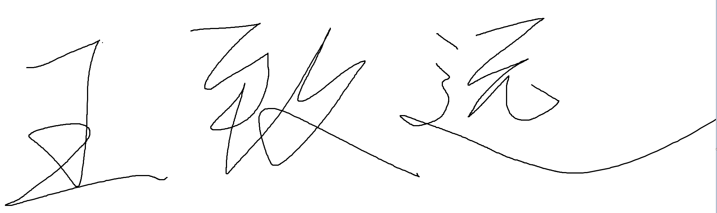

Date:15/5/2022